PRESENTING CLINICAL SIGNS
History: No information provided.
-Sedation used: Midazolam and Torbugesic IV.
-STAT: Not requested.

ECHOCARDIOGRAM FINDINGS
2D, m-mode, color flow and doppler imaging is available. The left ventricular wall is mildly increased in dimension (PW > IVS). There is a diffusely hyperechoic endocardium consistent with fibrosis. Mild symmetric papillary muscle hypertrophy and remodeling. The right ventricle is subjectively normal in size and morphology. There is no left atrial enlargement present. No right atrial enlargement present. Normal RVOT velocity. Trace TR. Normal LVOT velocity. There is no obvious systolic anterior motion (SAM) of the mitral valve present. No MR. There is no pericardial effusion noted. No pleural effusion appreciated. No obvious cardiac tumors.

CARDIAC CHART
FELINE  CARDIAC  PARAMETERS | BODY WEIGHT  (kg) | HR  (BPM) | IVSd  (cm)  (Moise, Pipers) | LVIDd  (cm)  (Moise, Pipers) | LVWd  (cm)  (Moise, Pipers) | FS  (%) | EF  (%)
NORMAL PARAMETER | ------ | 150-240 | 3.5-0.55 | <2  (mean 1.5) | 3.5-0.55 | 35-67 | 80-100
PATIENT | 8.0 | 142 | 0.57 | 1.0 | 0.68 | 46 | 81
FELINE  CARDIAC  PARAMETERS | LA/AO  (Boon) | LA/AO  HEART BASE  (Swe)  (Abbott) | LA  2D short axis  Base view  (cm)  (Abbott) |  | LVOT VEL  (m/s) | RVOT VEL  (m/s) | E max  (m/s)
NORMAL | <1.5 | <1.3 | <1.2 |  | <1.6 | <1.3 | <0.9
PATIENT | NM | 1.2 | 1.2 |  | 0.85 | 0.5 | NM
Adapted from June Boon, Veterinary Echocardiography,1998
Abbott J & MacLean H JVIM 2006;20: 111-119, Moise et al. Am J Vet Res 47:1476, 1986. Pipers et al. Am J Vet Res 40:882, 1979.

INTERPRETATION OF THE FINDINGS & FURTHER RECOMMENDATIONS
Hypertrophic cardiomyopathy (HCM) is a rule out diagnosis once a patient is deemed normotensive and euthyroid. Both should be ruled out in this case as contributing factors. The degree of disease is mild and asymptomatic, with only mild focal LVH and no LA dilation. This would indicate the risk for clinical issues is low at this time. No additional issues are identified.

No medications are indicated prior to significant atrial dilation. It is important to note that no medications have been shown to definitively alter long term outcome at this stage, particularly in the absence of SAM.

Monitor at home for any respiratory issues or signs of blood clot events (neurologic change, paralysis, etc.). Anesthetic risk is considered mild, however judicious fluid administration is advised if needed with careful RR/RE monitoring to screen for fluid overload. Additionally, drugs that stimulate heart rate should be avoided unless clinically necessary (glycopyrrolate, atropine). Risk for complication with steroid use typically follows LA dilation, which in this case is mildly elevated. If needed, monitoring of RR/RE is advised particularly in the initiation phase.

PLAN
A screening blood pressure and T4 are recommended, then every 6 months lifelong.

A recheck echocardiogram is recommended in 6 months to assess for progression, sooner if any issues arise in the interim.

IMAGES
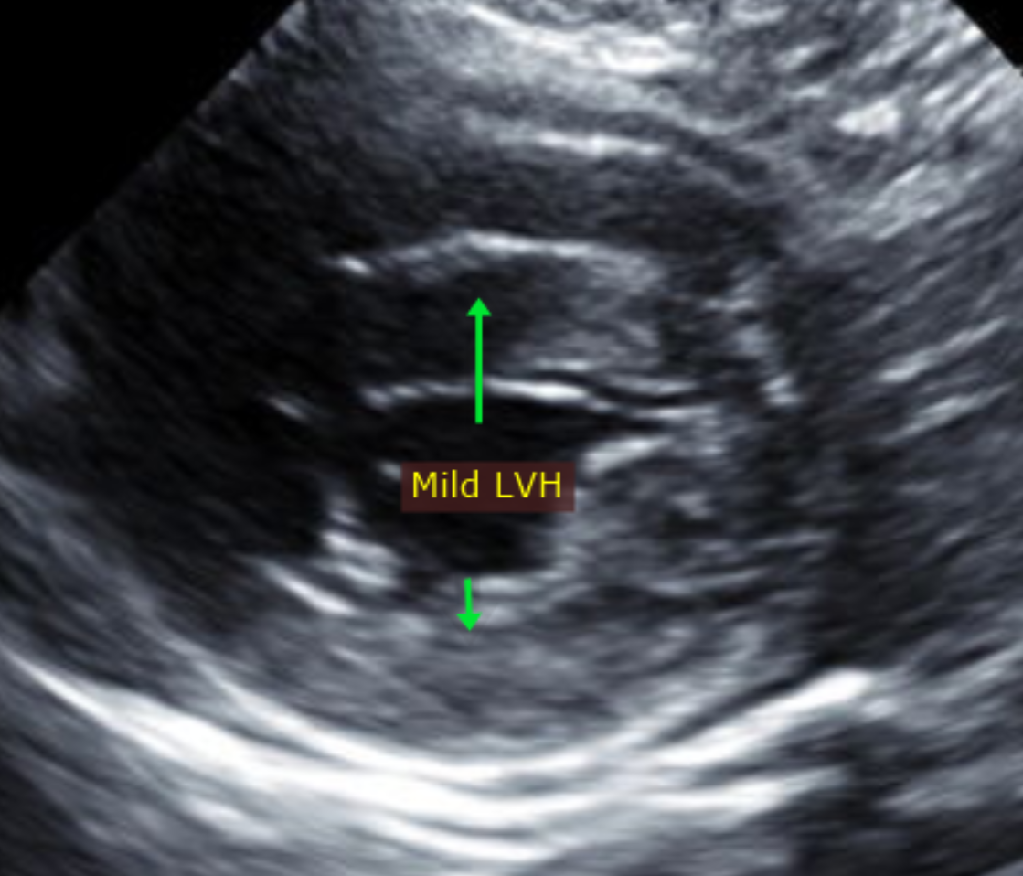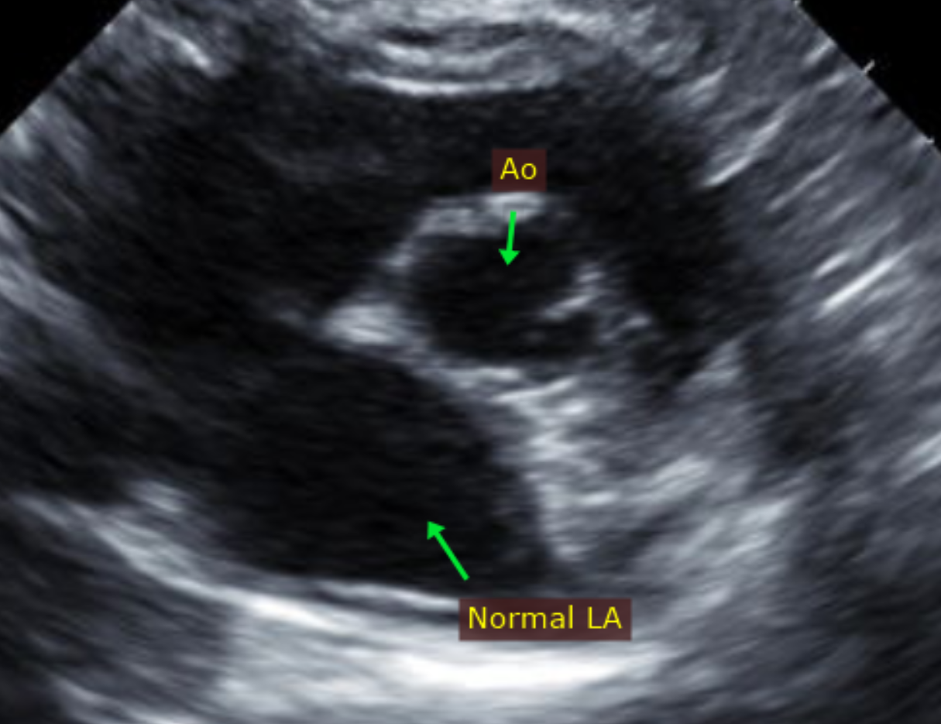

The information and recommendations provided are based on the images presented by the referring veterinarian. No evaluation can be communicated regarding pathology that was not visible in the image/video clips provided.

Thank you for this referral. This report was generated using transcription software, and minor dictation errors may be present. If the clinical or image interpretation does not parallel your findings or if I can be of any further assistance, please contact me.

Maggie Machen Lamy, DVM
Diplomate of the American College of Veterinary Internal Medicine (Cardiology)

